Paper Details
Journal | Open Journal of Nursing (OJN)
Paper Title | Salsa Dance could Improve Effectively to Body Balance in Elderly with Risk of Falls (1441066)
Comment
No.1 | The effect of dance on the body balance of the elderly was investigated. The topic was very interesting and the results were significant. The minor comments are as following:  1. More keywords were necessary.  2. ‘training 20 times for 7 weeks’, ‘4 months from July 2017 until October 2017’, it was two months or four months.  3. In section Results, the subsection was mistakenly marked.  4. Table 1, the median age was 65 while the max age was 65 for intervention group.  5. The all intervention was female while there were male in control group. Please explain.  6. The data in table 3 and table 5 was different. It was better to delete table 5.  7. A subsection, Ethical considerations was missing.

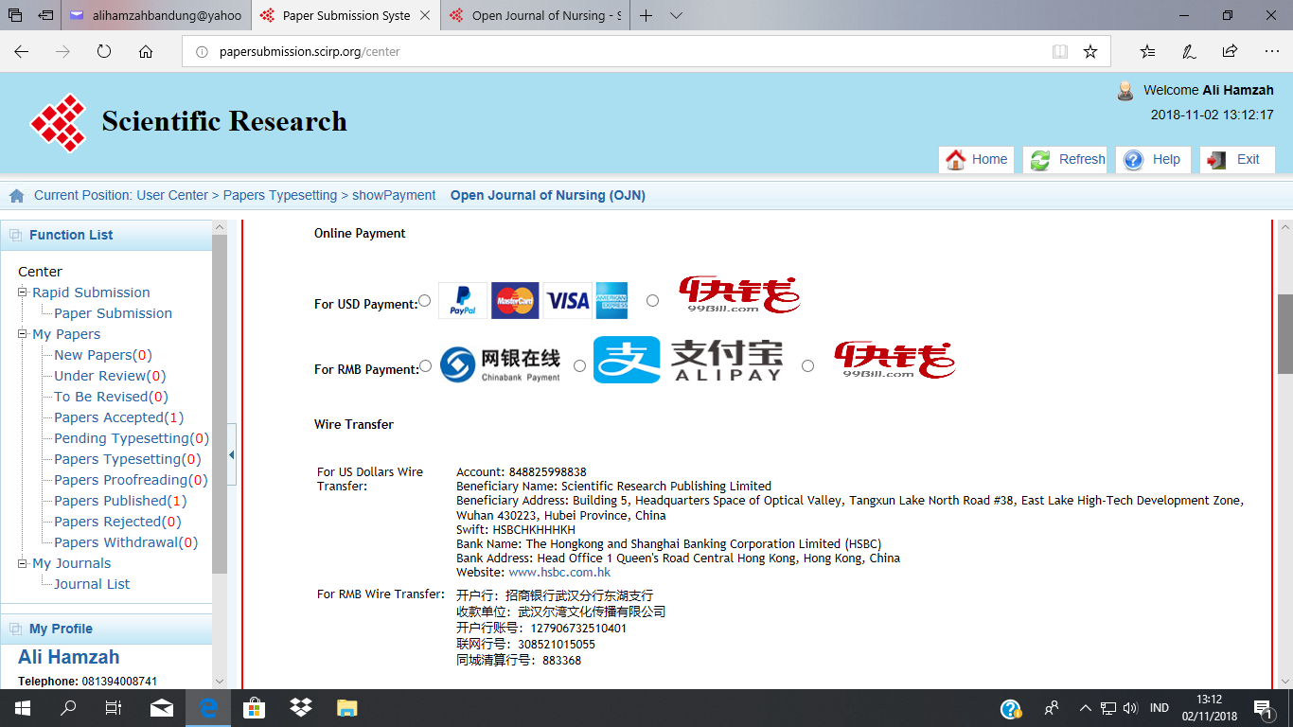

Scientific Research Publishing, Inc.
SCIRP, http://www.scirp.org

OJN COPYRIGHT FORM
This form is intended for original material submitted to the Journal Open Journal of Nursing (OJN) published by Scientific Research Publishing Inc. (SCIRP). The following agreement must be signed and returned to the OJN Editorial Office before the manuscript can be published. Please read it carefully and keep a copy for your files.

Journal: | Open Journal of Nursing (OJN)
Paper ID: | 1441066
Paper Title:
Author(s): | Ali Hamzah

COPYRIGHT Authorization AGREEMENT

The undersigned hereby grants SCIRP a nonexclusive copyright that may exist in and to the above Work, and any revised or expanded derivative works submitted to the Journal OJN by the undersigned based on the Work on the understanding that
• on completion of the layout SCIRP will make the final paper available online without delay,
• SCIRP guarantees that no university library or individual reader will ever have to buy a subscription or buy access through pay-per-view fees to access the papers published in the Journal OJN.

The undersigned hereby warrants that the Work is original and that he/she is the author of the Work; to the extent the Work incorporates text passages, figures, data or other material from the works of others, the undersigned has obtained any necessary permission including permission from any and all co-authors.

RETAINED RIGHTS, TERMS, AND CONDITIONS

Since the undersigned grants SCIRP a nonexclusive copyright, the undersigned retains the original copyright while SCIRP is granted the same set of rights including the right to sublicense the Work.

SCIRP will publish the Work under a Creative Commons license. By default This is the Creative Commons Attribution 4.0 International License, CC BY:
http://creativecommons.org/licenses/by/4.0/.

Alternatively upon request it is also possible for SCIRP to publish under: Creative Commons Attribution-NonCommercial 4.0 International License, CC BY-NC:
http://creativecommons.org/licenses/by-nc/4.0/.

Author’s choice (specify CC BY-NC only if you do not want the default CC BY): .

Authors and their employers retain all proprietary rights in any process, procedure, or article of manufacture described in the Work.

Authors who are US Government employees may reproduce or authorize others to reproduce the Work, material extracted verbatim from the Work, or derivative works to the extent permissible under US’s law for works authored by US Government employees, and for the author’s personal use or for company or organizational use, provided that the source and any SCIRP copyright notice are indicated, the copies are not used in any way that implies SCIRP endorsement of a product or service of any employer, and the copies themselves are not offered for sale.

In the case of a Work performed under a China Government contract or grant, the SCIRP recognizes that the China Government has royalty-free permission to reproduce all or portions of the Work, and to authorize others to do so, for official China Government purposes only, if the contract/grant so requires.

SCIRP Copyright

It is the formal policy of SCIRP to be granted the nonexclusive copyrights to all copyrightable material in its technical publications and to the individual contributions contained therein, in order to protect the interests of SCIRP, its authors and their employers, and, at the same time, to facilitate the appropriate re-use of this material by others. SCIRP distributes its technical publications throughout the world and does so by various means such as hard copy, microfiche, microfilm, and electronic media. It also abstracts and may translate its publications, and articles contained therein, for inclusion in various compendiums, collective works, databases and similar publications.

No royalties are paid to authors if SCIRP produces revenues by these activities.

Author/Employer Rights

If you are employed and prepared the Work on a subject within the scope of your employment, the copyright in the Work belongs to your employer as a work-for-hire. In that case, SCIRP assumes that when you sign this Form, you are authorized to do so by your employer and that your employer has consented to granting the nonexclusive copyright, to the representation and warranty of publication rights, and to all other terms and conditions of this Form. If such authorization and consent has not been given to you, an authorized representative of your employer should sign this Form as the Author.

In the event the above work is not accepted and published by SCIRP or is withdrawn by the author(s) before acceptance by SCIRP, the foregoing granting the nonexclusive copyright shall become null and void and all materials embodying the Work submitted to OJN will be destroyed.
The author signs for and accepts responsibility for releasing this material on behalf of any and all co-authors.

Dear Dr. Ali Hamzah,

Hope this email finds you well.

Enclosed is the galley proof of your paper, please check it carefully to see if there are any problems.

We have pointed out one or several corrections in yellow with comments aside in the typeset proof which need to be made or confirmed. (If there is no yellow mark, please ignore this.)

Also, the words in red are what we corrected according to the grammar. Please also confirm them. (If there is no red word, please ignore this.)

Please highlight the revisions in other colors or send me a cover letter on what you want to revise in 2 days.

All the corrections or amendments required after the publication of this article online will be released in the upcoming issue as a corrigendum. Extra payments will be required if a corrigendum is needed after publication.

We expect your response. Thank you for your support and cooperation.

Best regards,

Tracy Tian
OJN Editorial Assistant
Skype: tracytian0902@outlook.com
QQ: 1063949158

Dear Author,

This is from the Editorial Office of Scientific Research Publishing.

Dear Dr. Ali Hamzah, Sri Kusmiyati and Endeh Nurgiwiati
Greetings from Open Journal of Nursing.
This is to inform you that your paper entitled "Salsa Dance could Improve Effectively to Body Balance in Elderly with Risk of Falls" has been accepted for publication.
This manuscript will be ready for publication if the following three procedures can be completed within a week:
Step 1: Complete the Copyright Transfer
Step 2: Make Payment for Article Processing Charge $500. (The payment information shown in your user center is the only correct and certified information; please do not be misled by other uncertified payment notification.)
Step 3: Revise the paper according to the comments on the system and Format it in our template, and Upload revised version in Word format through the system. Please highlight the revisions in red color in the updated version and send us a response letter on the comments if available. (The template and review comments are available on the system. Please send the reformatted file via email if the size of it is more than 4MB.)
Please login to the online system with your account and password to view all the information.
We have sent the acceptance letter to you before, but in case you did not receive it, we therefore decide to send this letter again. We apologize for the inconvenience caused and appreciate your understanding.
If you have any papers to be published in the future, please send them to our mailbox directly.
If you have any inquiries, please feel free to contact us.

Best regards,

Vanessa Cheng
Editorial Assistant

