PROCEEDING
The 3rd Jogja Rendezvous for Innovation and Transformation in Medical Education (JIT)
2019

Excellence in Teaching and Learning in Health Professions Education

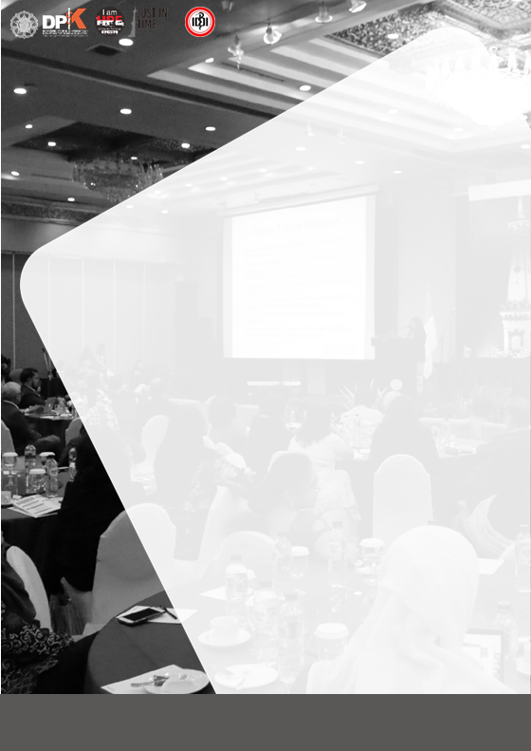

The 3rd Jogja Rendezvous for Innovation and Transformation in Medical Education (Just in Time)

Excellence in Teaching and Learning in Health Professions Education

Yogyakarta, 4th - 6th March, 2019

Editor:
dr. Mora Claramita, MHPE, PhD dr. Hikmawati Nurokhmanti, MSc

Reviewer:
dr. Hikmawati Nurokhmanti, MSc
dr. Ahsanudin Attamimi, SpOG(K), MMedEd dr. Siti Rokhmah Projosasmito, MEd(L,P&C) dr. Widya Wasityastuti, MSc, MMedEd, PhD dr. Yoyo Suhoyo, MMedEd, PhD
Dr. dr. Eti Nurwening, MMedEd, MKes

Department of Medical Education Faculty of Medicine - Universitas Gadjah Mada

The 3rd Jogja Rendezvous for Innovation and Transformation in Medical Education (Just in Time)
“Excellence in Teaching and Learning in Health Professions Education”

STEERING COMMITTEE
Prof. Ova Emilia, MD, MMedEd, PhD, SpOG(K) - Dean of FKKMK-Universitas Gadjah Mada Prof. Gandes Retno Rahayu, MD, MMedEd, PhD - Vice Dean for Academic and Student Affairs of FKKMK-Universitas Gadjah Mada

ORGANIZING COMMITTEE
dr. Mora Claramita,MHPE, PhD dr. Yoyo Suhoyo, MMedEd, PhD Widyandana, MHPE, PhD, Sp.M
dr. Rachmadya Nur Nidayah, MSc, PhD dr. Savitri Shitarukmi, MHPE
Trisia Yoenami Ratih Nurhayati, SFil
Maharani Pambudi Astuti,SSi dr. Yoyo Suhoyo, MMedEd, PhD drg. Agnes Bhakti Pratiwi, MPH dr. Hikmawati Nurokhmanti, MSc dr. Noviarina Kurniawati, MSc
dr. Widyandana, MHPE, PhD, Sp.M dr. Wika Hartanti, MIH
Rilani Riskiyana, SKep, Ns, MMedEd dr. Prattama Santoso Utomo, MHPEd
dr.Siti Rokhmah Projosasmito, Med, (L,P&C) dr. Rachmadya Nur Nidayah, MSc, PhD Aking Sandi Pribadi
Elizabeth Sulastri Nugraheni Gisella Anastasia
I Gusti Ayu Harry Sundariyati Lisa Lestari
Muliati Dolofu Muh. Idham Rahman Oscar Gilang Purnajati
Saverina Nungky Dian Hapsari Tyas Setia Nugraha
Annisa Nurul Huda, SGz Muhamad Farid
Sumartono Ekwar Triyanto
Ratih Nurhayati, SFil Dyah Nuswarini, Amd Muhammad Nur Ludfi

Welcome Message

The development of knowledge in the field of medicine and health as a result of demographic changes in the recent years, led to the shifting of disease burden and distribution. This phenomenon transformed health care systems and patients, including the need of high quality of care by health care professionals.

The increasing demand of health care professionals is followed by the increasing numbers of medical and health care professions education institutions. Consequently, the need for innovation in curricula, teaching and learning methods, and learning resources, become significant for the institutions to produce competent health care professionals. How the leaders and educators in health care professions education overcome these challenges, is the key to a better health care system.

Jogja Rendezvous for Transformation and Innovation in Medical Education (JUST IN TIME) held by the Faculty of Medicine, Public Health, and Nursing Universitas Gadja Mada, invites leaders and educators in Indonesia to join the national seminar discussing the Excellence in Teaching and Learning in Health Professional Education. This is an opportunity for leaders, educators and those who have the same vision, to connect and collaborate, to learn and update, for a better health care professions education in Indonesia.

Chairman

Mora Claramita, MD, MHPE, PhD

- Agenda. 1
- Curriculum Vitae 4
- Short Communications 17
- The Winners 21
- Full Papers 22
Wico Hartantri Qualitative exploration of indonesian student perception
23
of “the perfect” problem -based learning tutor

Relationship between student perceptions of problem

Satrio Wicaksono

Fatma Sylvana Dewi Harahap

Ashaeryanto
based learning (pbl) and the application of self directed 39 learning (sdl) at faculty of medicine of halu oleo
university

Religion as morals of education leadership and management of midwifery in indonesia: in perspective of 47

the leader women and children hospital and college

ofhealth budi kemuliaan jakarta

The correlation of intrinsic motivation with self -directed learning implementation in the faculty of medicine of 56
halu oleo university of kendari

Sri Mulyati Studi penelusuran alumni jurusan kebidanan bandung poltekkes kemenkes bandung
66

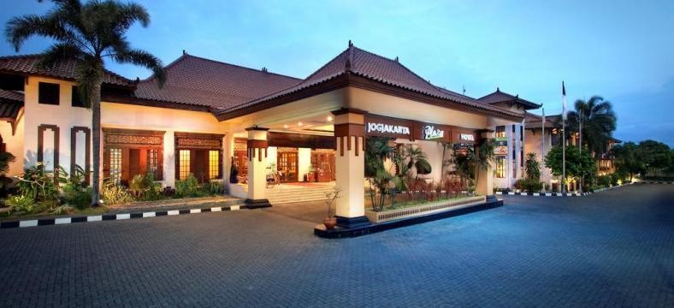
- Documentation. 79

in Medical Education (Just in Time) 2019
AGENDA

Day 1: Monday, 4 March 2019
Time | Agenda | PIC
12.30 – 13.00 | Registration for participants | MC:  Naya
13.00 – 13.10 | Opening | Prof. Dr. Ir. Djagal Wiseso Marseno, M.Agr  Vice Rector of Academic and Students Affairs UGM
13.10 – 13.15 | Introduction of keynote speakers: CVs | Moderator:  Prof. Gandes Retno Rahayu, MD, MMedEd, PhD
13.15 – 15.15 | Preparing health  professional education institution towards 4.0 era | Keynote speakers:  Prof. Ali Gufron Mukti,MD. M.Sc,  Ph.D  (Ministry of Research, Technology and  Higher Education Republic of Indonesia)
15.15 – 17.00 | Establishing network and collaboration of health professional education institutions towards 4.0 era | Sugiyanto,S.Pd.,M.App.Sc  (Head of Board for Development and Empowerment Human Resource of Health, Ministry of Health Republic of Indonesia)
17.00-17.15 | Wrap Up and Closing  Remark | Moderator

Day 2: Tuesday, 5 March 2019
Time | Agenda | PIC
08.00 – 12.00 | Dies Natalis FK-KMK UGM | JIT Participant may join
12.00 – 13.00 | Lunch
13.10 – 13.15 | Introduction of keynote  speakers: CVs | Moderator:  Mora Claramita, M.D, M.H.P.E, Ph.D.
13.15 – 13.45 | Seminar:  “FAIMER Institute: Fifteen Years Educating the World – key leaderships in medical  and health professions | John J. Norcini, Ph.D.  (President and CEO of the FAIMER Institute)

in Medical Education (Just in Time) 2019

education to approach
SDGs.”
13.45 – 14.15 | Seminar:  “Improving Capacity of Health Care Workforce Based on Evidence Based Practice in Medical and Health Professions  Education.” | Prof. Ara Tekian, M.D., Ph.D., M.H.P.E. (University Illinois Chicago Departement Medical Education)
14.15 – 14.45 | Discussion | Moderator:  Mora Claramita, M.D., M.H.P.E., Ph.D.
14.45 – 15.30 | Break
15.30 – 17.00 | Short Communication Free Papers | Moderator:  Yoyo Suhoyo, MD, M.Med.Ed., Ph.D. Siti Rokhmah Projosasmito,
17.00 – 17.30 | Alumni Day (Launching of regional  training) | Yoyo Suhoyo, MD, M.Med.Ed., Ph.D.
17.30-18.00 | Closing day 1 | MC

Day 3: Wednesday, 6 March 2019
Time | Agenda | PIC
08.00 – 08.30 | Registration
08.20 – 08.30 | Opening Session | MC:  Naya
08.30 – 09.30 | Panel Discussion: Establishing effective multi- institutional network collaboration | - John J. Norcini, Ph.D. (FAIMER Institute)  - Prof. Dr. Med. Tri Hanggono Ahmad,  M.D. (Rector of Universitas Padjadjaran)  - Sugiyanto,S.Pd.,M.App.Sc (Head of BPPSDMK RI)  - Prof Ova Emilia, MD, M.Med.Ed, Ph.D. Sp.OG(K) (Dean of FK-KMK UGM)  Moderator:  Prof. Gandes Retno Rahayu, MD, MMedEd, Ph.D.
 | Each panelist: 15 minutes speech

in Medical Education (Just in Time) 2019

09.30 – 10.00 | Discussion | Moderator:  Prof. Gandes Retno Rahayu, MD,  MMedEd, PhD
10.00 – 10.30 | Coffee break
10.30 – 11.30 | Panel discussion:  Improving Teaching and Learning in Postgraduate Clinical Education (Residency) Curriculum  Each panelist: 20 minutes speech | - Prof. Ara Tekian, MD, Ph.D, MHPE (University Illinois Chicago  Departement Medical Education)  - dr. Ardi Findyartini, Ph.D (Universitas Indonesia)  - Prof. Dr. Nancy Margarita Rehatta, MD, Sp.An- Sp.An.KIC.KNA.KMN (Universitas Airlangga)  Moderator:  Yoyo Suhoyo, MD, M.Med.Ed., Ph.D.
11.30 – 12.00 | Discussion | Moderator:  Yoyo Suhoyo, MD, M.Med.Ed., Ph.D
12.00 – 13.00 | Break
13.00 – 14.45 | Workshop range of selection:  - Workshop practical guide of Nursing  - Workshop practical guide of workplace- based assessment  - Workshop practical guide of Entrustable Professional Activity  Parallel with IAM-HPE meeting | - Dr. Heny Suseani Pangastuti, SKp, MKes  - dr. Yoyo Suhoyo, MMedEd, PhD  - dr. Titi Savitri Prihatiningsih, MA, MMedEd, PhD
14.45 – 15.30 | Break
15.30 – 17.00 | Workshop range of selection:  - Workshop practical guide of OSCE  - Workshop practical guide of Facilitating clinical skills training  - Workshop practical guide of IPE | - dr. Hikmawati Nurokhmanti, MSc  - dr. Ide Pustaka Setiawan, MSc, Sp.OG  - dr. Amandha Boy Timor Randitha, MMedEd
17.00 – 17.30 | Closing | MC

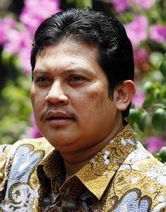
SPEAKERS

Prof. dr. Ali Ghufron Mukti, M.Sc., Ph.D.
Director General of Science, Technology and Higher Education Resources
Ministry of Research, Technology and Higher Education Republic of Indonesia

Date of birth: Blitar, 17 May, 1962

Bussines Address:
Kementerian Riset, Teknologi dan Pendidikan Tinggi
Direktorat Jenderal Sumber Daya Ilmu Pengetahuan, Teknologi dan Pendidikan Tinggi
Lantai 5 Gedung D Kementerian Ristek Dikti Jln. Jenderal Sudirman, Pintu I Senayan Jakarta Pusat

Education:
Degree | Year | Institution | Field
Medical doctor | 1986/1988 | Gadjah Mada University, Faculty of Medicine,  Yogyakarta, Indonesia | Medicine
MSc | 1991 | Mahidol University,  Thailand | Tropical  Hygiene
PhD | 2000 | University of Newcastle,  Australia | Medicine

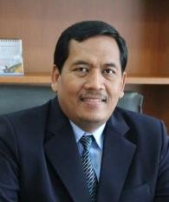
in Medical Education (Just in Time) 2019

Sugiyanto,S.Pd.,M.App.Sc
Head of Board for Development and Empowerment Human Resource of Health, Ministry of Health Republic of Indonesia

Date of birth: Kulonprogo, 22 Juli 1966

Address:
Jl. Bergota Husada 18
RT 007/RW 005 Randusari Semarang Selatan
Office phone: +62 21-7255429 Email: sugiyanto@kemkes.go.id

Education:
Degree Institution Field
S.Pd IKIP PGRI Semarang Bahasa & Sastra Inggris

Diploma IV Royal Melbourne Institute of Technology Australia
M.App.Sc Royal Melbourne Institute of Technology Australia
Teknik Radiology

Keteknisian Medis

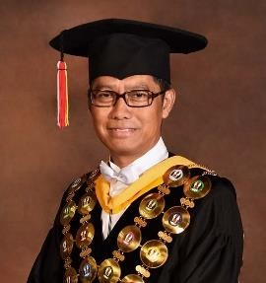
in Medical Education (Just in Time) 2019

Prof. Dr. med. Tri Hanggono Achmad, MD
Rector of Universitas Padjadjaran

Date of birth: Bandung, 22 September, 1962

Bussines Address:
Jalan Eijkman No. 38 Bandung, 40161 Jalan Raya Bandung-Sumedang Km. 21

Education:
Degree Year Institution Field
Medical doctor | 1987 | Universitas Padjadjaran | Medicine
Course | 1990 | Inter University Centre – Institute of | Genetic
 |  | Technology Bandung, | enginering
Course | 1991 | Inter University Centre – Institute of | Molecular
 |  | Technology Bandung, | Biology
Short Course | 1992 | Bad Onheuysen – Germany | Animal Research
 |  |  | Technology
Doctor | 1995 | Institute of Clinical Biochemistry, | Clinical
 |  | School of Medicine, University of | Biochemistry
 |  | Bonn, Germany
Fellowship | 2000 | Educational Commission for Foreign | Medical
 |  | Medical | Education
 |  | Graduate, USA
Course | 2001 | Universitas Padjadjaran | Applied
 |  |  | Approach (AA)
Dean’s Course | 2010 | German Academic Exchange Service | Higher Education
 |  | Fachhochschule Osnabrueck- | Development
 |  | German Rector’s Conference-
 |  | Central for Higher Education
 |  | Development, Osnabrueck-Berlin

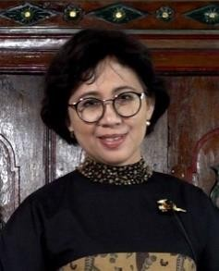
in Medical Education (Just in Time) 2019

Prof. dr. Ova Emilia, MMedEd, PhD, SpOG(K)
Dean of Faculty Medicine, Public Health, and Nursing Universitas Gadjah Mada

Date of birth: Yogyakarta, February 19, 1964

Bussines Address:
Department of Obstetrics & Gynecology, Faculty of Medicine, Gadjah Mada University. DR. Sardjito Hospital, Yogyakarta, INDONESIA
Telephone: +62-274-587333 ext. 283 / 62-274-511329
Email: ovaemilia@yahoo.com.au

Education:
Degree Year Institution Field

Medical doctor 1989 Gadjah Mada University,
Faculty of Medicine, Yogyakarta, Indonesia
Medicine

Diploma in Medical Education
 |  | Dundee, Scotland, UK
Master of Medical | 1991 | Centre for Medical | Medical
Education |  | Education, University of | education
 |  | Dundee, Scotland, UK
Medical Specialist | 2000 | Faculty of Medicine, | Obstetrics&
 |  | Gadjah Mada | Gynecology
 |  | Univ.Yogyakarta
PhD | 2000-2004 | University of New South | Clinical
 |  | Wales, Sydney Australia | Teaching
Specialist Consultant | 2009 | Faculty of Medicine, | Obstetrics
 |  | Gadjah Mada | Gynecology
 |  | Univ.Yogyakarta | Social

1990 Centre for Medical
Education, University of
Medical education

in Medical Education (Just in Time) 2019

John J. Norcini Jr.
President and Chief Executive Officer of the Foundation for Advancement of International Medical Education and Research (FAIMER)

Date of birth: April 30, 1952

Bussines Address:
Foundation for Advancement of International Medical Education and Research (FAIMER®)
3624 Market Street, 4th Floor, Philadelphia, Pennsylvania 19104 Telephone: 215-823-2170
Email:jnorcini@faimer.org

Education:
Department of Education and Child Development, Bryn Mawr College Ph.D. in Child Development and Counseling, Spring 1981.

Department of Psychology, LaSalle University
B.A. in Psychology, Spring 1974

