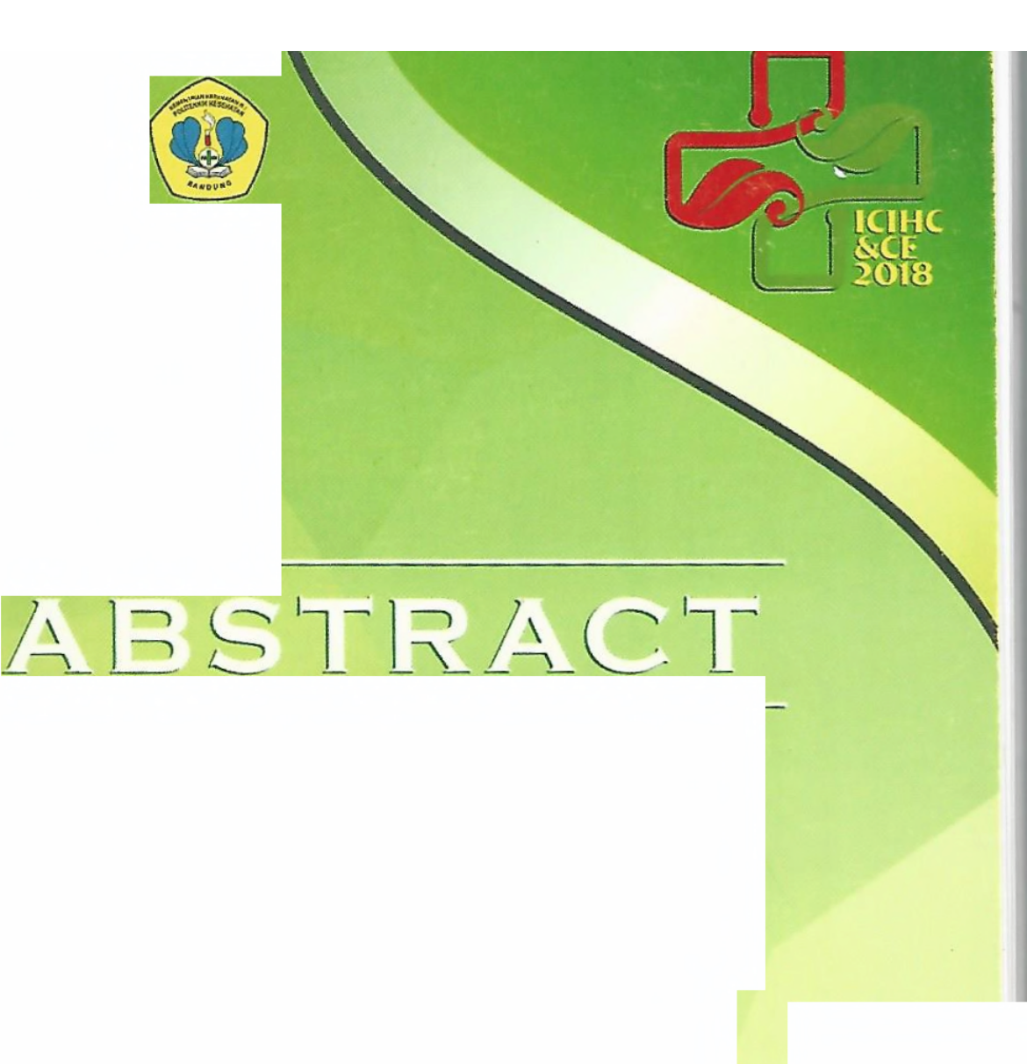KE KE RE INOO

MENTERIAN SEHATAN PUBLIK
NESIA

1sT INTERNATIONAL CONFERENCE ON INTERPROFESSIONAL HEALTH COLLABORATION AND COMMUNITY EMPOWERMENT
e and Behavior of Pregnant Women for HIV Test

Knowledg
In PITC Mobile Services at Bandung City

Ida Widiawati ', Cherly Marlina1, Yulinda1, Saur Saryati1
'Bandung Midwivery Departement Politeknik Kesehatan Bandung
Email : dawiwidi@yahoo.co.id

Abstract

Background : The Ministry of Health has developed of Human Immunodeficiency Virus (HIV) test service with the application of Provider Initiated Testing and Counseling (PITC) since 2010 which is carried out as part of Maternal and Child Health services where HIV testing is offered by service officers to pregnant women who access services in health facility. However, PITC services have not been optimally utilized by pregnant women. The report from the Ministry of Health in 2018 that the pregnant women who have done for HIV testing and detected as having sexually transmitted infections (STis) there were 8,862 cases of pregnant women from 147,202. The aim of the study was to analyze the relationship comprehensive knowledge with the behavior of HIV testing in the PITC program at Bandung City.
Method : The method of cross sectional study with the amount of sample 76 respondents. Analysis with chi-square test to collect data using a questionnaire. Result: The research results showed that variable of knowledge and history of STis are related significantly with HIV testing behavior in PICT services with p value (<0.05). Respondents who had never experienced STI had chance 3.6 times not to take an HIV test while respondents who had knowledge less get a chance 14.7 chance of not taking an HIV test.
Conclusion : It is suggested that health workers conducting PITC in ANC services provide health information I education both individually and in groups so that respondents have good knowledge before taking an HIV test.

Keywords: HIV testing, PITC, knowledge

Abstract Boak
International Conference on lnterprofessional Health Collaboration 6 Community Empowerment

Management of Urinary Incontinence trough Kegel Exercise in Elderly in
Bandung

Ridwan Setiawan1, Cherly Martina 1, Euis Nurhayati1
Health Promotion Department, Poltekkes Bandung
Email: iwan_najwa@yahoo.com

Abstract

L
b
b
L:
L
L
L-·
Background : urinary incontinence is one of which is found at age clients.Urinary incontinence estimated prevalence ranges from 15 % - 30 % age in public and 20-30 % geriatrics patients treated at hospital, and probably increase heavy incontinence urinnya 25-30 % when i was 65-74 year. The complications can be with the urine as an elimination urinary infections, a disorder of sleep, a social issue higiene who eventually causing social isolation, stress, a wound, blisters, no less important to the treatment costs and high
.Various ways and means to reduce an elimination urine been devoted to problems, one way through the exercise kegel simulation
Method : With assessing the elimination urine with use instruments PPKEU in
Posbindu RW 06, conducting guidance kegel exercise by volunteers who have been trained especially on the first I night, and by students at noon
Result : In kelurahan pamoyanan of 16 those who follow pre test there are 2
people having the value of the above 5 and gsg pamoyanan from 22 participants who take pre test there are two a person who has a score of above 5 who follow pre test there are two a person who has a score of above 5 , but other senior citizens were not as kegel simulation by reason to anticipate what is not desirable. After extensive work was done over the less is more gymnastic kegel exercises four months under guidance cadres and supervision from ibm team the results of post test all senior citizens who follow kegel activities having the value of the simulation below 5 which means that it is strong in control of miksi and better levels of muscle power.
Conclusion : kegel exercises carried on elderly, effective to strengthen the basic pelvis used for therapeutic on someone who cannot control the urination.

Keywords: elderly, kegel exercises, urine

Abstract Book
International Conference on lnterprofessional Health Collaboration 6 Community Empowerment

The Effectiveness Health Promotion through The Video On Knowledge Of Premenstrual Syndrome And Dismenorhoe in Adolescent Women at SMPN I And SMPN IX

Cherly Madina 1, Sulastri 1, Budi Setyono1
Health Promotion Department, Poltekkes Bandung
Email: cherlvmarlina@vahoo.com

Abstract

Background : Teenagersare the next generation that determines the success of this nation in the future ,however ,naturally in the process of development adolescents often face many conflicts and problems. Premenstrual syndrome and dysmenorrhea are problems that woman often experienced before or during menstruation .According to WHO there are 60-75 % of woman in the world experiencing menstrual disorders. In indonesia the incidence of dysmenorrhea is uncertain,there is very little treatment, which is around 1-2 %. Lack of knowledge about reproductive health, especially menstruation in young woman has animpacton readinessin yhe face of menarche which can cause positive or negative reactions during menstruation. Audiovisual media has two elements, each of which has the power that will synergize into a great power. This mediaprovides a stimulus to hearing and vision. So that the results obtainedare maximized.
Method : this research using design a quasi experiment .Design used in research is one group pretest posttest namely expresses the causation in a manner involving one group subject, the subject in observation before intervention and then in observation again after done intervention.
Result : media audio visual in this research the use of video education health about dismenorhoe and pre menstrual syndrome with the results obtained the statistical testing p = 0,012 where the value ofp & it; 0,05 so there is a significant difference between knowledge before and after given intervention .Expected media video and become one of the media used to perform education and the provision of information related to teen health.
Conclusion : significant knowledge among both the intervention and the control group .And the media in this research the use of audio and visual video in education and health about dismenorhoe pre menstrual statistical testing with the results of the syndrome there is no statistical difference between knowledge before and after the intervention.

Keywords: health promotion, premenstrual syndrome, dismenorhoe

Abstract Book
International Conference on lnterprofessional Health Collaboration 6 Community Empowerment
mpowerment in Increasing Body, Teeth & Mouth, and

The Society E
Reproduction
Health in RW 06 Cipageran, North Cimahi, Cimahi City.

Ridwan Setiawan 1, Cherly Marlina 1, Euis Nurhayati 1, Ferina2, Chris Sriyanti2,
Seni Rahayu2, Hera Numaningsih 3
Health Promotion Department, Poltekkes Bandung Bandung Midwifery Department, Poltekkes Bandung Dental Health Department, Poltekkes Bandung

Email: iwan_najwa@yahoo.com

Abstract

Background : The cleanliness of the self is the Act of maintaining hygiene and health of one's self for the physical and psychological well-being, public health is a tool that is used for the prevention of disease and promotion of good health of individuals, families and the community. Individual community hygiene can reduce the threat of infectious diseases. Environment of the community including the school environment where the individual is going to come into play a role in the formation of the person's behavior, therefore, to change the behavior of the required roles and society where the individual is located. Immediate environment where individuals are namely family environment and more broadly i.e. school environment. Here the role of parents and teachers is very decisive in changing behaviour in the maintenance of oral health, child health and hand• washing the genitalia. The activities of the lbW does is public and personal training in RW 06 Kelurahan ofCipageran sub-district ofCimahi North
Method : The survey and sampling for determining the amount of teenagers I 0-19 years old at rw 06 cipageran village, in cimahi north, the city cimahi.The training method for
peer leader who will become role models in doing maintenance hygiene themselves Result : There is an understanding that increasing imprison him for good start from one way of brush their teeth and washing your hands is the fundamental must a sound understanding and pembiasaan in accordance with the principles in order to get optimal health .As for the result of the work being done by a team ibw. As for the result of the work being done by a team ibw, giving spirit and enough new information in adolescents
. And influential on the increase in penegetahuan teenagers , it is expected that this will affect healthy lifestyles for the youth in the life of a day the day nor the hour reproductive health.
Conclusion: Increased understanding and their ability to take care of hygiene ourselves
and the establishment of the peer group or the gang health care aged IO to 19 years in in our neighborhood 06 village cipageran in north cipageran cimahi village, in cimahi north, the city cimahi.

Keywords: hygiene, teenagers, reproductive

Abstract Book
International Conference on lnterprofessional Health Collaboration 6 Community Empowerment

w

.//' -<(
Cl)
z
0 (!)
CzZ:::::, I.LI
-c
LLz

tu
+-I
'-
~
O<(
om ::J
-...J UJ
mw
:::>.z~

~

.....
o
.....

...r..o....
......c...
c:e

v,
~ c

9-c~

er,
ro
"C
..Q..).
ro

Q
~
.......,
+,iii
re

c:
~
n:: :E
I.I.
...0......
1-a :e w
Q) c.. CJ
WW o T5 ~
ro
J:W
.!!2 tu
I- er,
c.. ~
er, -
I
::::s I- -o ca (1)
~ C1) - = (1)
~~ ..c
I-
ro (..) E
c:
:l:
.c: ·u-,
0
"'O
I
!!!.
ns
E > (.) c c
c
..... 0
:.J Cl)
<Cw
~ ~
~ C1) J: 'O u,
0,
@......-:
w~ ~
~ 0 .fl) <...) I- e :::J c ~ @

J:~

I.LI

I.. c: ""cC:
O
;..J
w
-ca
.o...

"'cO
m

i:~<
~~
u.w o
(lJ
0
<...) ca
ca
~ c"-: .c!: cu
~ .(.1..) -
~~~:
;;~g
~:::~
0 !:i
a.
u c: ~ 0 v
........ c:
ca 0
;:;

[t:
I- ....:.
·.;:.:.::.:
:I:
..C...1..). z:::J ~
-c: C>
1n ·e-
-.r- 'O
-

..c:
C1)
:::J
0
....... e

c:
·-0 ........
ca u,
..... (1)
u,
0 ca
.c (1)
-ca .!!?
-0 c
u,
<...) :::J
..c: ....
0
-ca J!!
........
0
:c - ....
c: .c:
C1)
"-- -;
ca ........ - :::J (1)
c: c: .2 :IS
·-0 C1) oJ: >ca -e
ti) E <(o .c: (1)
ti) ..... 0::: a, E
.fl) C1);:: 0. al c:
~ 0
0..... 0. .c: .:!::: '-~
c.. 0 <( :::: > (1)
c.. >- ca e .c
..... E (1) w E
........C1) w ;..J:iE J: 'O (1)
c: .c:- c: 0
- ........>a <( .... ca c
(1)
c: LL ca u,
-~
·- (1) (1)
0 c: J: J: u, U)
-z
:E-
c:

